**Supplementary materials**

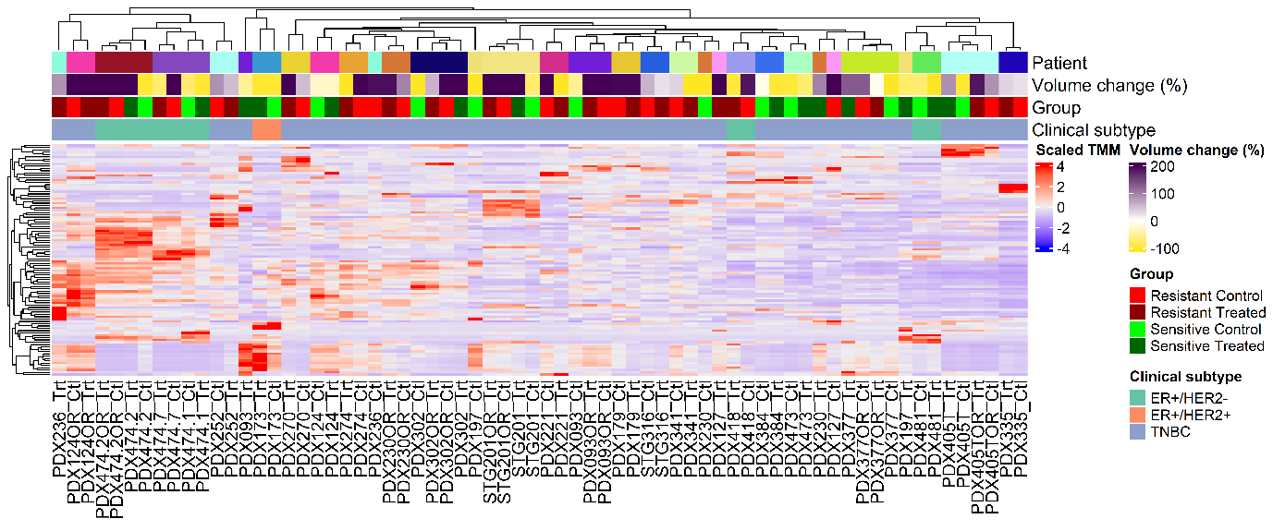

**Supp. Figure 1.** Heatmap of gene-scaled TMM of 100 most variable genes with sample annotations of patient of origin, tumour volume change in percentage, group and breast cancer clinical subtype.

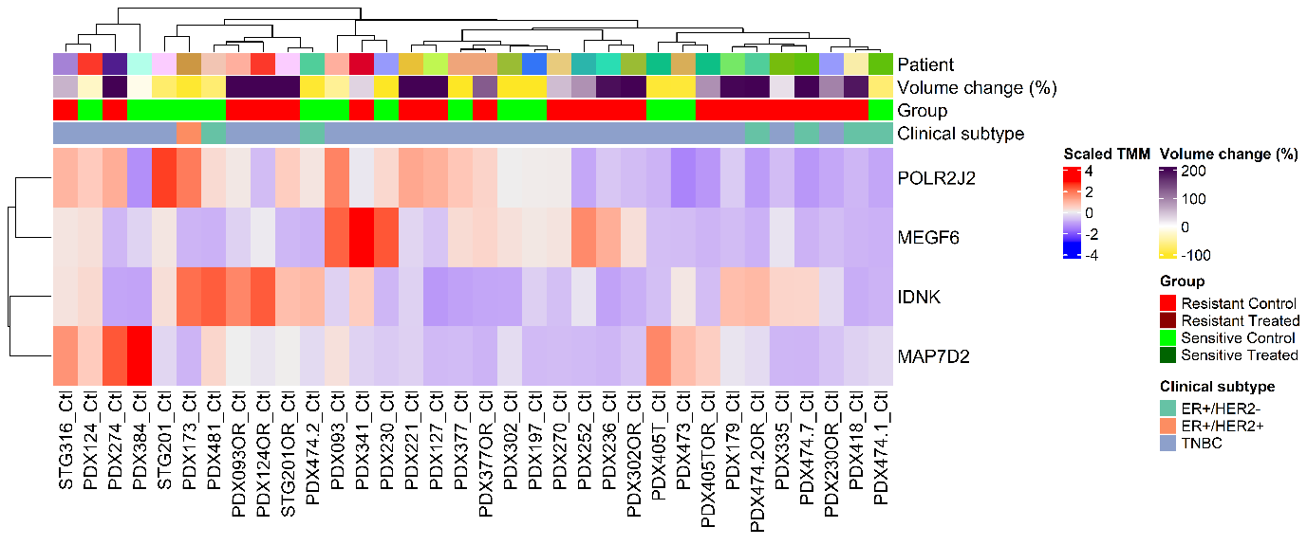

**Supp. Figure 2.** Heatmap of gene-scaled TMM of differentially expressed genes between sensitive against resistant controls. Sample annotations show patient of origin, tumour volume change in percentage, group and breast cancer clinical subtype.

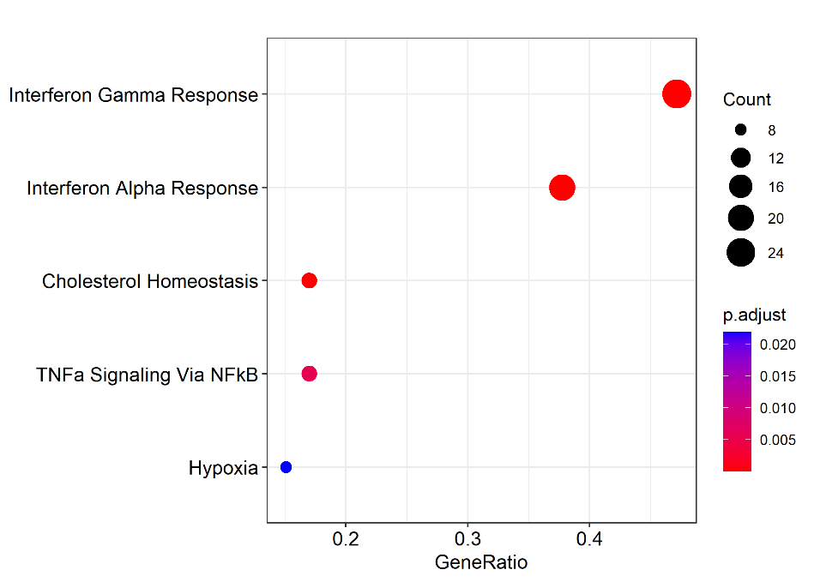

**Supp. Figure 3.** Dot plot of over representation analysis of differentially expressed genes in treated against control sensitives. The adjusted p-value corresponds to BH correction.

Sensitive vs resistant treated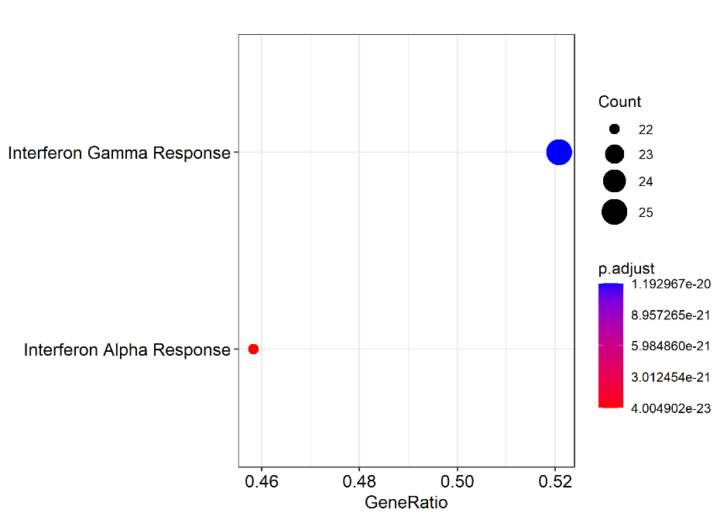

Supp. Figure 4. Dot plot of over representation analysis of differentially expressed genes in sensitive against resistant group upon treatment. The adjusted p-value corresponds to BH correction.